

**Dynamic Memory Allocation and List**

**DSA ASSIGNMENT II**



September 25, 2024

Aswin.s

RA2311026050067

Implementation of Matrix Multiplication using Dynamic Memory Allocation. Ensure to allocate the memory using appropriate functions and access the array using pointers

**Answer**

1. Implementation of Matrix Multiplication using Dynamic Memory Allocation. Ensure

to allocate the memory using appropriate functions and access the array using

pointers.

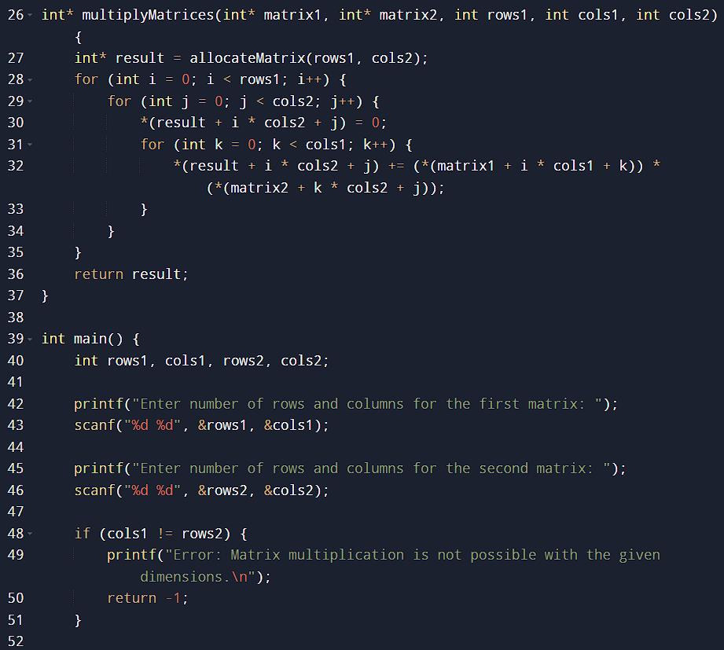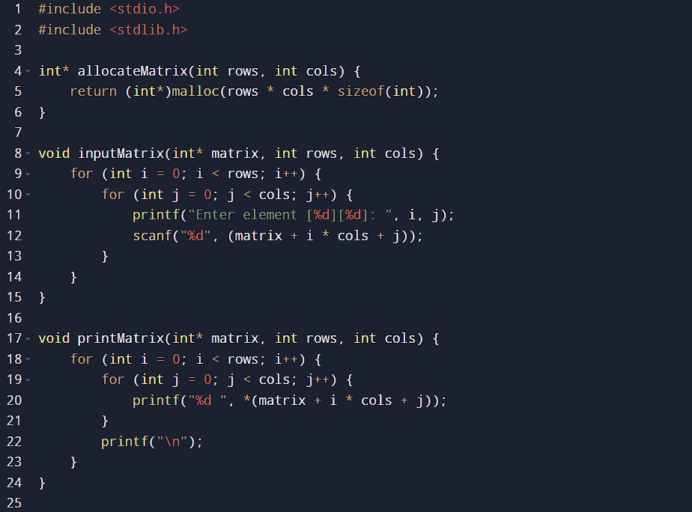

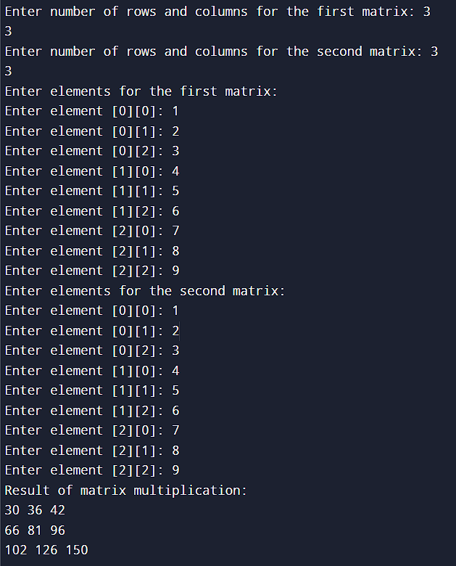

**2)** **2. You are given a task with creating a simple student management system using arrays that will allow the user to manage student names. Implement the following operations on a list of student names using switch-case and arrays. After every operation, display the current list of students.**

**The operations to implement are:**

**(i) Creation of the list: Allow the user to create a list of student names by entering them one by one..**

**(ii) Insertion of a new student: Insert a new student's name into a specific position in the list. The user should provide the name and the index at which it should be inserted.**

**(iii) Deletion of a student: Delete a student's name from the list based on their position or name. Ask the user whether they want to delete by name or by index.**

**(iv) Traversal of the list: Display all the student names in the current order.**

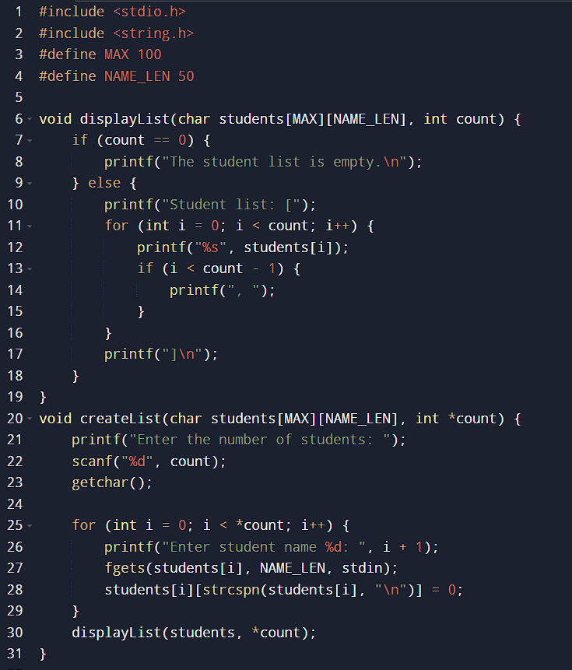**(v) Search for a student: Search for a student's name in the list and display whether or not the student is found, along with their position if present**

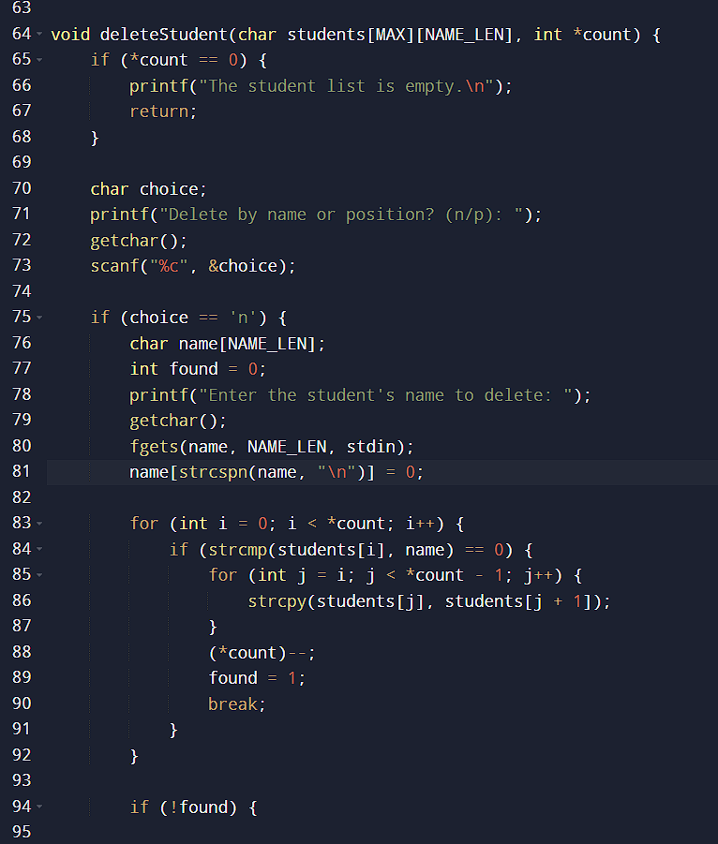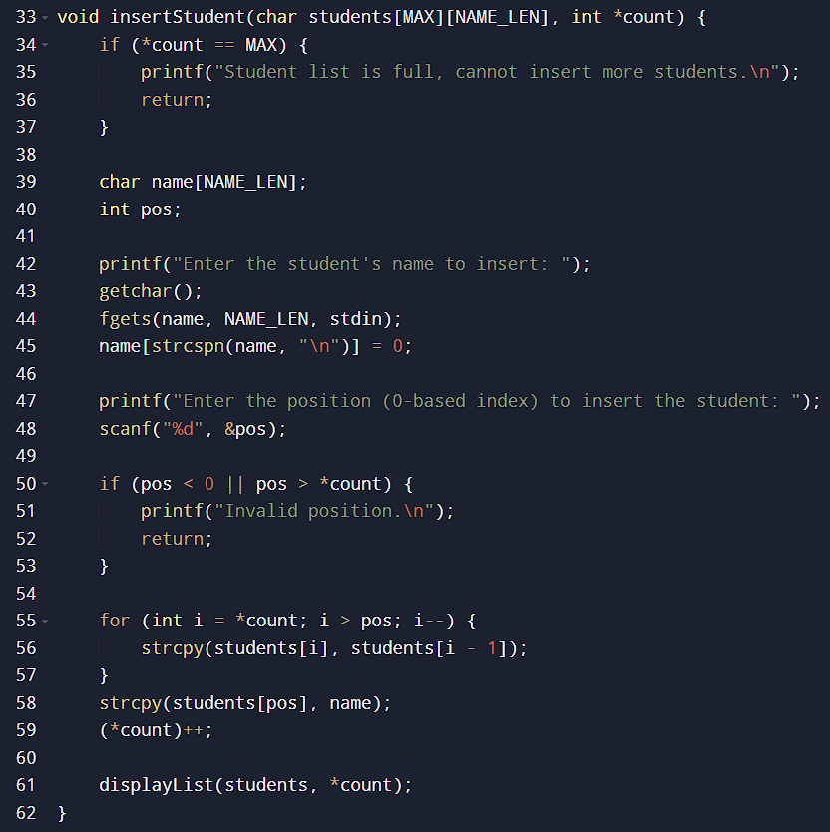

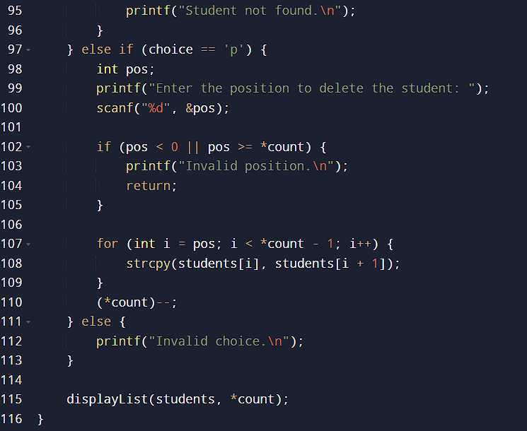

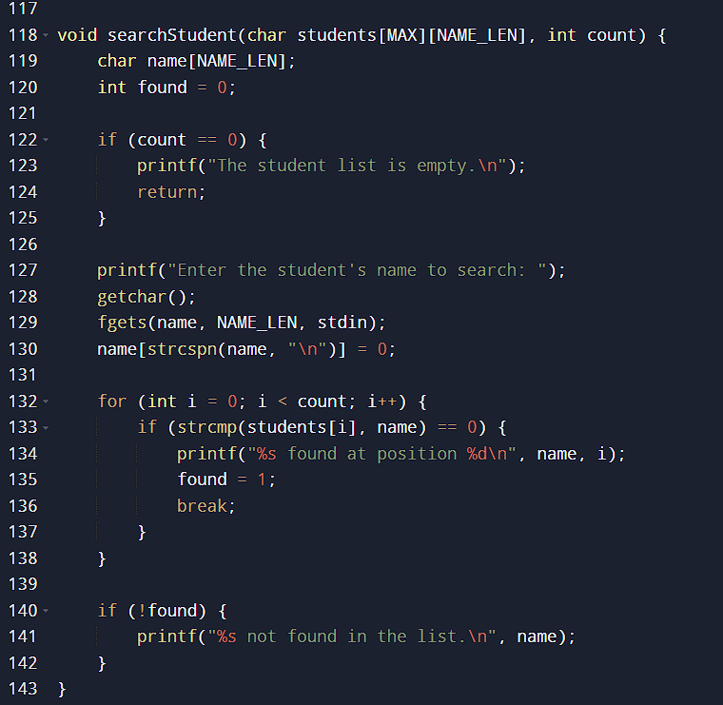

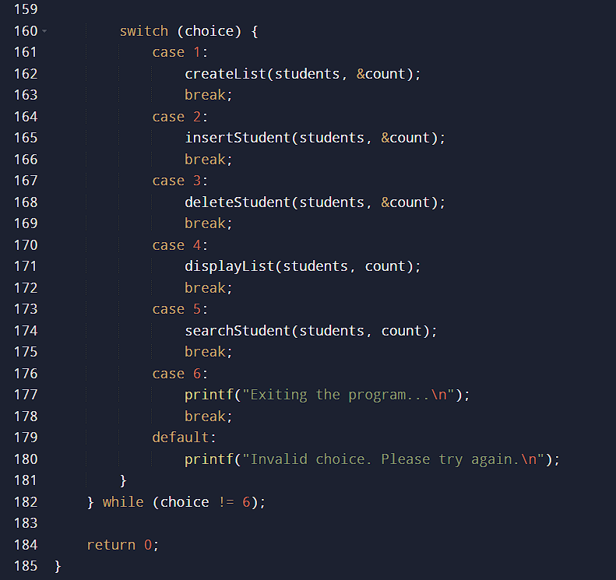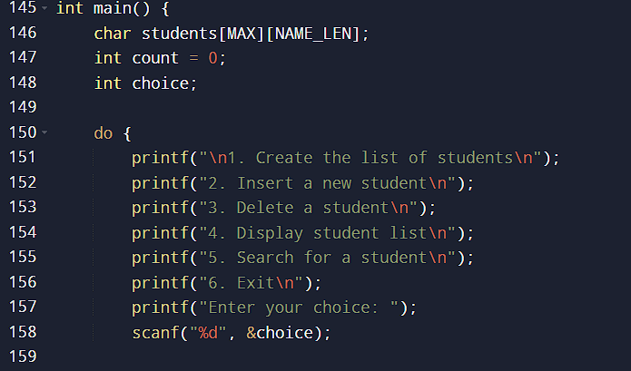

**Output:**



